CB[1] project: You can choose from the list of projects below (or convince me of a project you feel would be better), but you are required to do the following:

1. Choose one main factor and one blocking factor
2. Have at least three levels for the main factor.
3. Replicate at least 2 times for each main factor/block combination
4. Determine the best way to do randomization of your experiment, and describe your randomization process.
5. For the report, please include the following:
   1. Introduction
      1. What is your research question?

Do I make more baskets from 15 feet or 25 feet or 35 feet away into a laundry basket or does my wife make more out of 10?

* + 1. What are the null and alternative hypotheses?

Ho: Matt = Wife

Ha: at least one is different.

Ho: All distances are the same.

Ha: At least one is different.

* 1. Data Collection
     1. How did you randomize?

I used a random number generator in R and assigned the distance of 15 feet to 1 and the distance of 25 to 2 and 35 to 3 and I was 1 and my wife was 2 and used this until we were finished.

* + 1. What was the factor(s) and response?

Factors were distance of 15 feet and 25 feet or 35 feet away.

Response was how many shots made.

* 1. Factor Structure
     1. Create the factor structure
     2. Describe what design you planned on using

I plan on using the complete block design.

* 1. Descriptive Statistics
     1. Numerical Descriptive Statistics

1. distance min Q1 median Q3 max mean sd n missing
2. 1 15 1 3.75 5.0 6.5 10 5.250 2.815772 8 0
3. 2 25 0 1.75 4.0 6.5 8 4.125 3.044316 8 0
4. 3 35 4 4.00 6.5 8.0 9 6.250 2.052873 8 0
5. block min Q1 median Q3 max mean sd n missing
6. 1 husband 1 4.00 6.5 8 10 6.166667 2.622744 12 0
7. 2 wife 0 2.75 4.0 6 8 4.250000 2.527126 12 0
   * 1. Graphical Descriptive Statistics

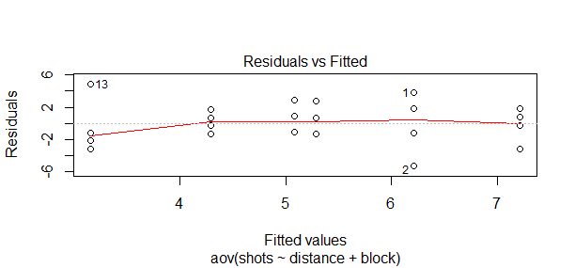

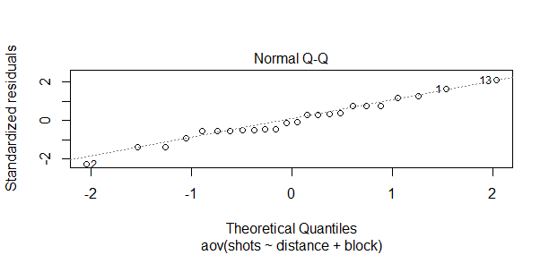

* + 1. “Tell a story” based on what you see in your descriptive statistics

The data is normally distributed and the equal variance in the residuals.

* 1. Inferential Statistics
     1. Checking Requirements

1. Levene's Test for Homogeneity of Variance (center = median)
2. Df F value Pr(>F)
3. group 2 0.3367 0.7179
4. 21
   * 1. ANOVA table, df,SS, MS, F, p-value

Analysis of Variance Table

Response: shots

Df Sum Sq Mean Sq F value Pr(>F)

distance 2 18.083 9.0417 1.4146 0.2663

block 1 22.042 22.0417 3.4485 0.0781 .

Residuals 20 127.833 6.3917

---

Signif. codes: 0 ‘\*\*\*’ 0.001 ‘\*\*’ 0.01 ‘\*’ 0.05 ‘.’ 0.1 ‘ ’ 1

* + 1. Decision rule (level of significance)
    2. Any mean differences or mean treatment combinations that stand out?

The mean of the different distances is different. It looks like the 35 feet is the most different. And the difference between mine and my wife’s means are different.

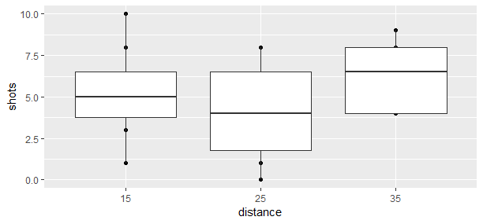

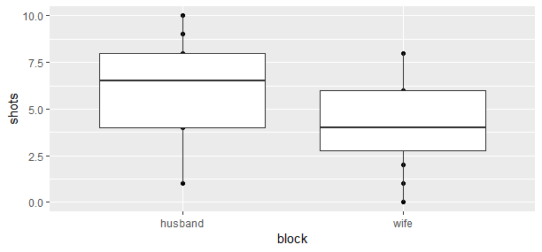

* 1. Conclusion
     1. General Conclusion of your results based on decision rule

There is no significance between the distance or the block and we accept the null hypothesis that the distance is equal and the different between me and my wife are equal.

* + 1. Why do you think you got the results you did?

We were shooting into a laundry basket and we throw things everyday playing with our son.

* + 1. What would you have done differently?

Done real basketball shots into a real hoop at different significant shots in basketball.

* + 1. Any follow up studies that you would have done?

Change the type of ball that we played with.

Different possible projects:

1. factors:

clothes dryer (A,B), temperature setting, load

responses:

time until dryer stops

1. factors:

pan (aluminum, iron), burner on stove, cover for pan (no, yes)

responses:

time to boil water

1. factors:

pack on back (no, yes), footwear (tennis shoes, boots), run (7, 14 flights of steps)

responses:

time required to run up steps and heartbeat at top

1. factors:

width to height ratio of paper sheet, slant angle, dihedral angle, weight added, thickness of paper

responses:

length of flight of paper airplane

1. factors:

brand of rubber band, size, temperature

responses:

length of rubber band before it broke

1. factors:

orientation of football, kick (ordinary, soccer style),steps taken before kick, shoe (soft, hard)

responses:

distance football was kicked

1. factors:

distance from basket type of shot, location on floor

responses:

number of shots made (out of 10) with basketball

1. factors:

temperature, position of glass when pouring soft drink, amount of sugar added

responses:

amount of foam produced when pouring soft drink into glass